**UPGRAD TASKS:**

**Task 1:**

After running **terraform init**

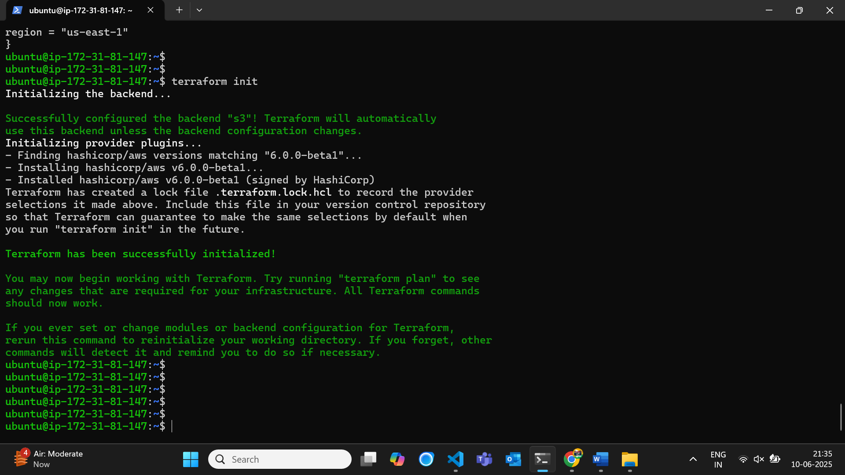

After running **terraform apply** for all ec2.tf, vpc.tf, sg.tf, and provider.tf

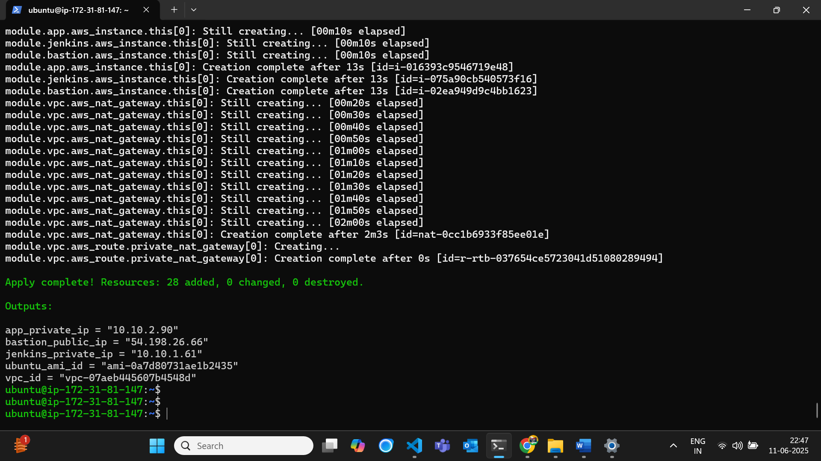

VPC Resource map (used **module** to create network)

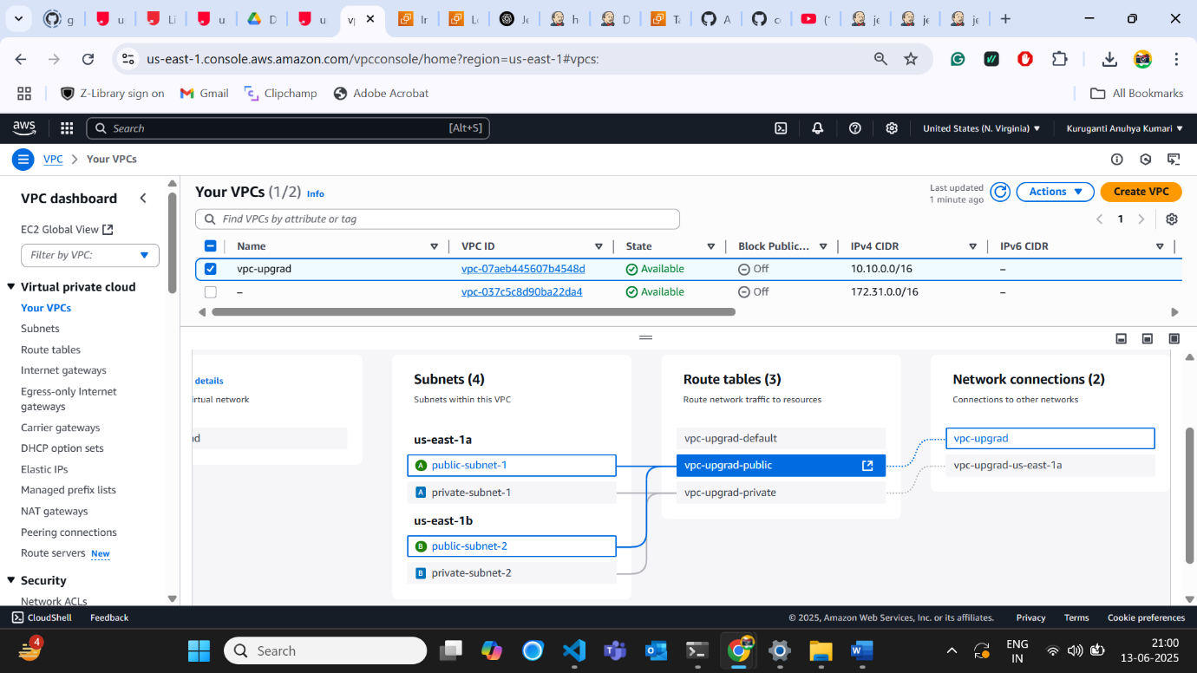

3 ec2 instances are created – bastion, Jenkins, app (bastion – in public security group, Jenkins & app – in private security group)

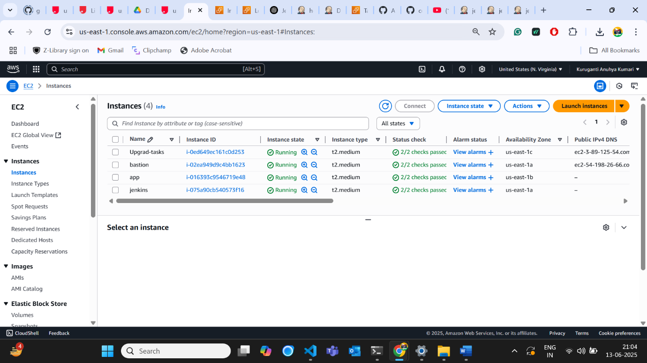

**Task 2:**

After running the command - **ansible all -m ping -i inventory** in ***bastion instance***

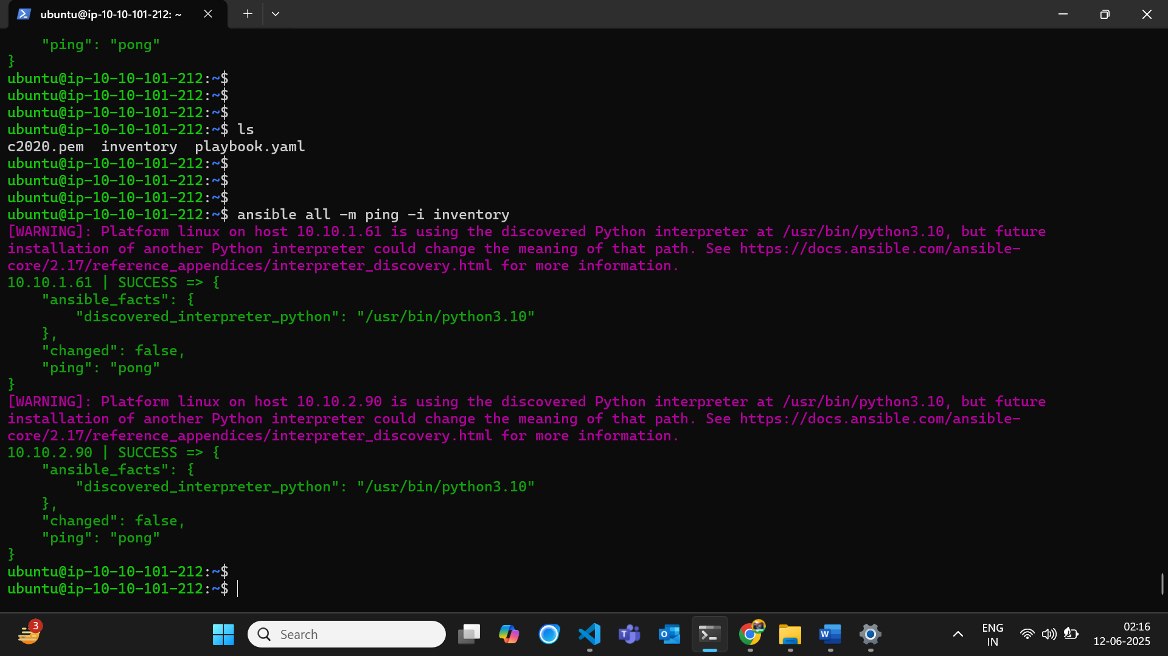

After running the command - **ansible-playbook playbook.yaml -i inventory** (docker installation in *Jenkins and app machines*)

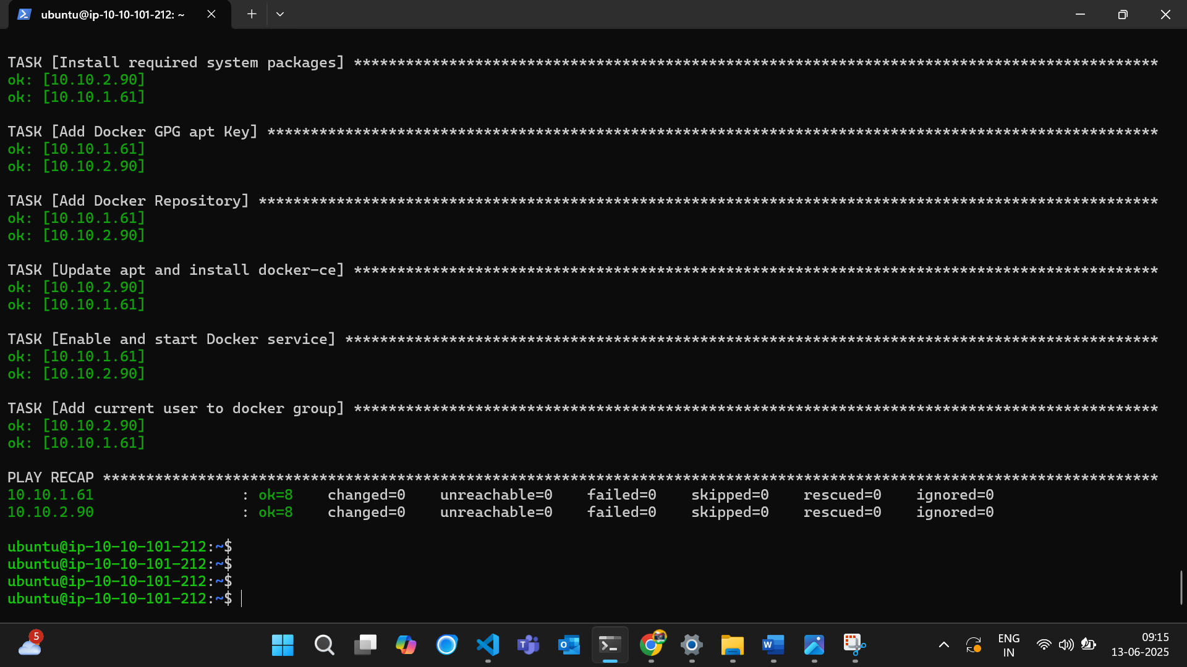

Checking docker installation:

1. Jenkins

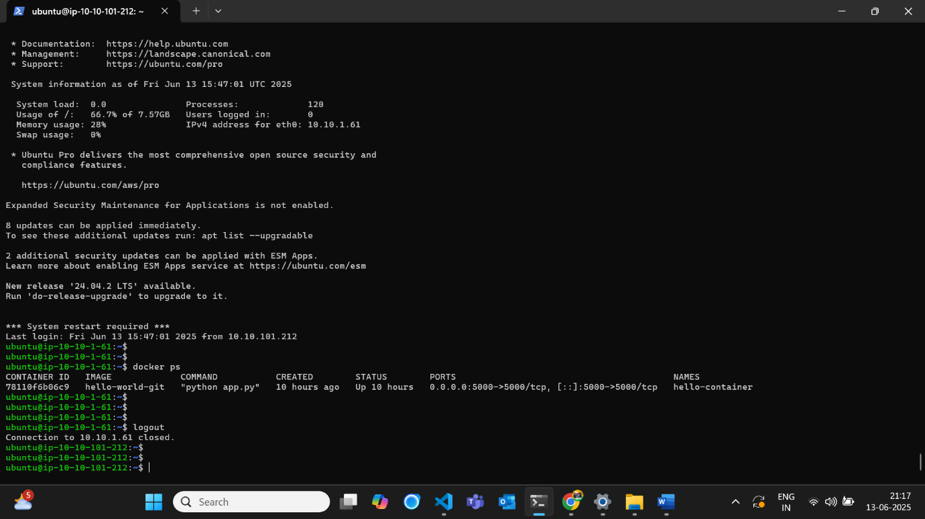

1. App

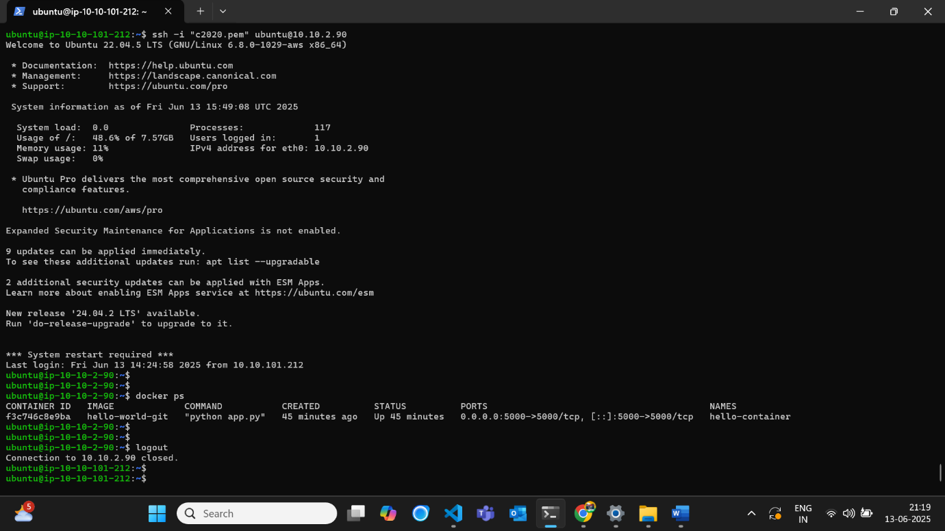

Checking alb_url/Jenkins

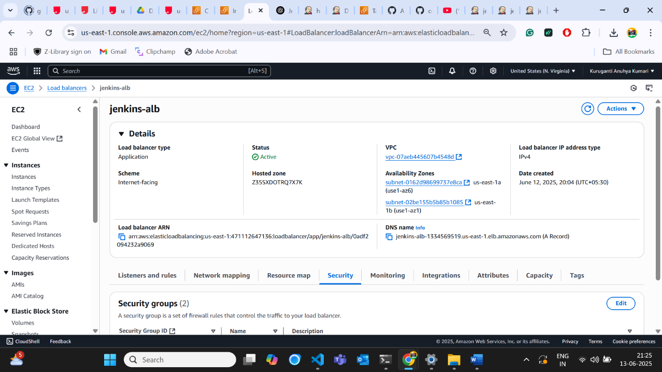

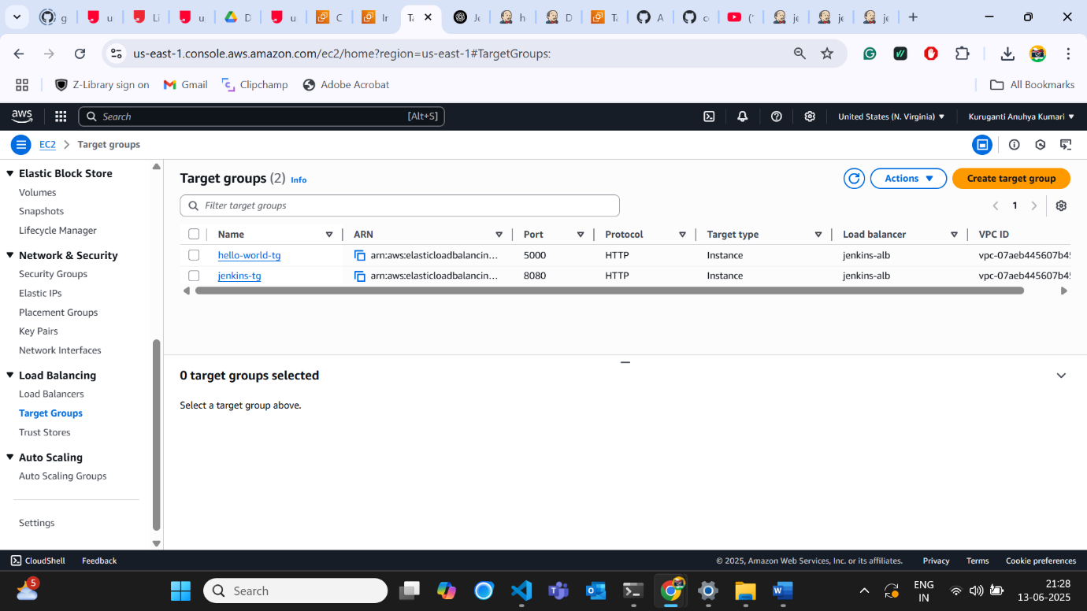

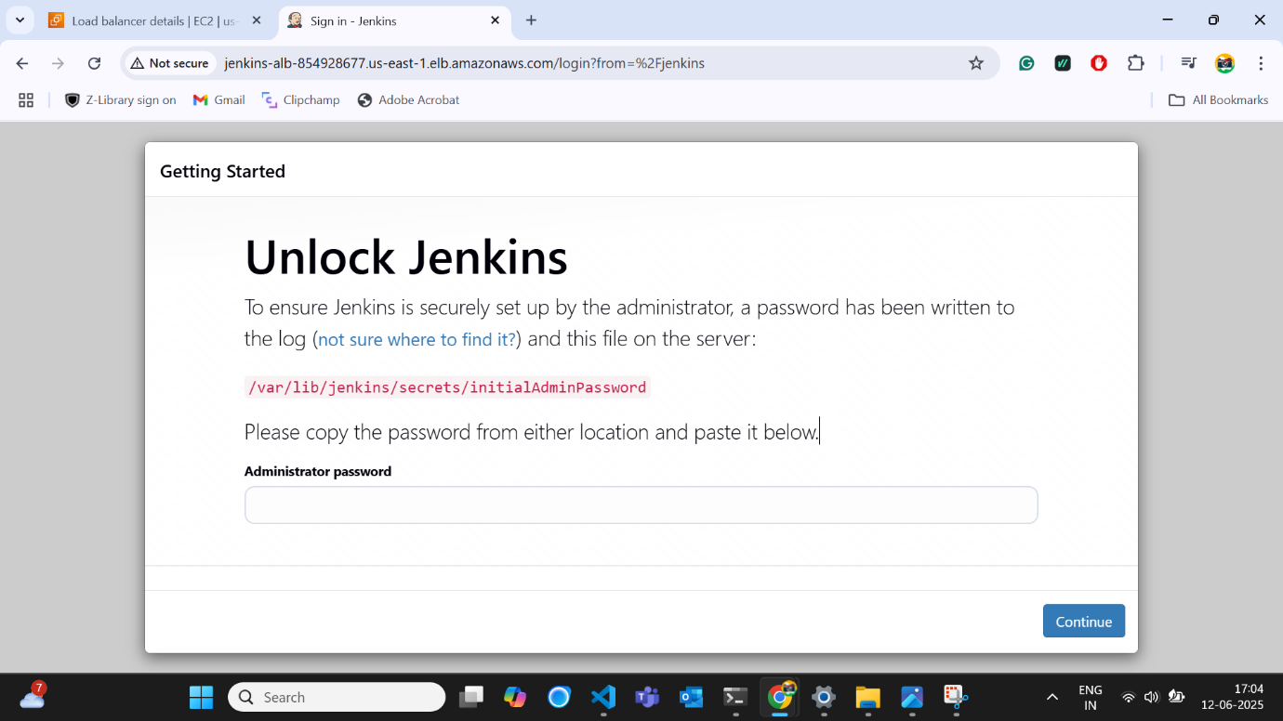

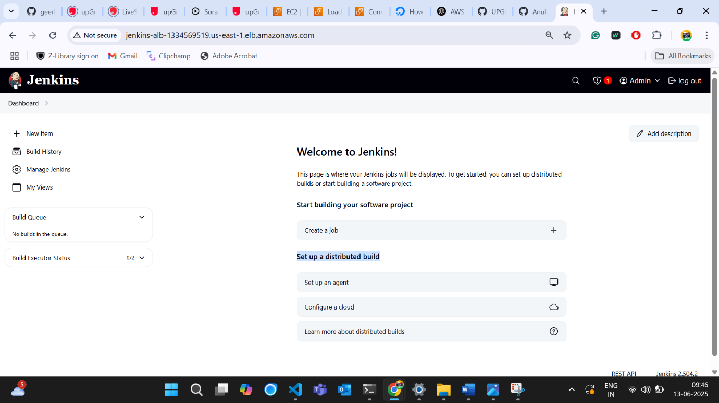

**Task 3:**

